Science
Observations with Etoys
Kindergarten - First Grade Levels

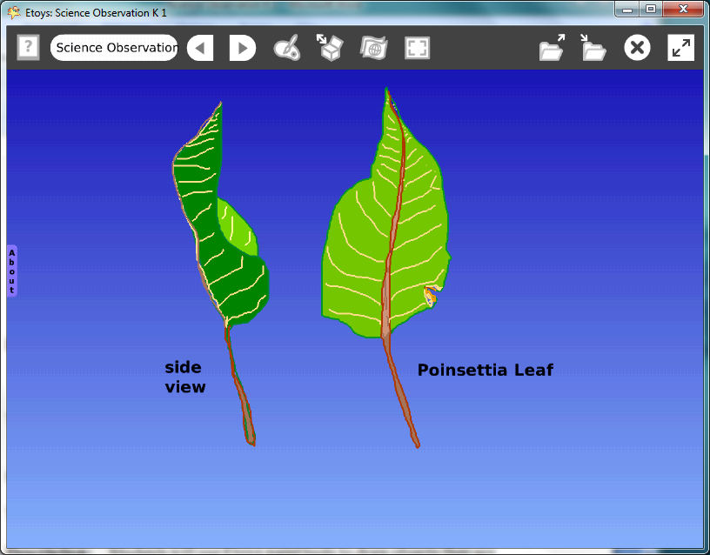

Introduction: | This project uses Etoys to record science observations. Technology makes it easy to try many ideas, to experiment with changes, and to save projects into one digital portfolio.
Topic: | Students use Etoys paint tools to record their science observations, knowledge, and ideas.
Subject: | Science
Time: | Lesson 1 Two labs
Description: | Students will use Etoys paint tools to draw objects they are studying in science.  This project topic is Biology: leaves.  The lesson introduces a vocabulary of words common in science, mathematics, and everyday experience.
Vocabulary: | leaf, blade, veins, margin, edge, petiole, texture, line, shape, size, design, pattern, duplicate, copy, above, below, beside, before, left, right, upper, lower, edge, near, up, down, between, almost, exactly, forward, turn, colors, textures
Evaluation Criteria: | Draws a leaf from two viewpoints: front and side view.  Can identify details, the blade, veins, and margin in their drawing of a leaf.  Observes and shows changes in color and shape of the leaf.  Works on observation drawings independently.
Teacher Information:  Etoys Quick Guides: Click the question mark in  Etoys to open the set of tutorials about basic tools and techniques. | Etoys Quick Guides: Click the question mark in  Etoys to open the set of tutorials about basic tools and techniques.  Use Etoys Quick Guides if the lesson mentions unfamiliar tools or techniques. Give students time to read them too.
Goals: | Students use Etoys paint tools to draw plants they observe for science class.
Lesson 1:  Two labs  Paint Tools: Brushes  Paint Tools: Color Palette  Paint Tools: Bucket Tool  Halo Handles: Viewer  Navigator Bar: Keep Find Projects | Remind students to think about the names of the parts of the leaf that they already know and to make sure they are showing all the parts: leaf blade, veins, and margin. The petiole is the little part that connects the leaf blade to the stem of the plant; this might be too specific for young children but on the other hand, many children have an inexhaustible supply of curiosity about new words and things.  Students can be expected to work independently after the paint tools have been introduced. Give them time to observe and to paint.  Draw a leaf. If the computer screen is glass, have students tape the leaf to the monitor and trace the leaf margin. Some students will be more confident if they trace the outline and then add details.  Remind them to notice and include color changes, holes, and other marks. Challenge them to show as much detail as they can see.  Add a beautiful colorful background to the World screen.  Open the World’s Viewer and click on basic to open a menu  Click on Fill and Border. Click a color to select it.  Click on the tiny green arrow to change ‘false’ to ‘true’ for gradient fill.  Publish the project  Type a name for the project. Example: nameLeafDate, kateLeafOct 08
Extend Lesson 1  Three labs  Supplies: Text | 1. Discuss  Ask students if they found all the colors they needed. Brown is hard for some children to find.  Did they draw the leaf the same size as the real one? Larger, Smaller?  How did they show the texture?  Could they show the smallest veins? What is inside the veins of leaves?  Are both sides of the leaf the same color and texture?  Ask children to think about the names of shapes like squares and circles. Could they use those words to describe leaf parts?  Ask students to put their drawings in a variety of screen locations.  Give students time to look at drawing by other students to see the detail and then to modify their drawing.  2. Draw the leaf from an edge view. Discuss the idea of observing and from different points of view.  Ask students to turn the leaf in their hand so they are looking at the leaf from the edge. They will see part of the front and part of the back of the leaf.  3. Draw the leaf looking at it from the leaf tip. This is a much harder perception problem for young children.  4. Add text to label the kind of leaf and its parts.  Vocabulary labels strengthen the acquisition of vocabulary. Students can type all the labels or they could draw letters with the paint tools.  5. Make drawings of other leaves: add to the project name, for example: kateoakleaffeb07
Student Information:

Standards: | Science  Illinois State Standards: Early Elementary Science  12A. Know and apply concepts that explain how living things  function, adapt, and change  Identify and describe the component parts of living things and  their major functions  Categorize living organisms using a variety of observable features  Mathematics  Illinois Performance Standards: Kindergarten  9B, 10A, 10B Data Collection  Gathering and organizing data  Noticing and describing relationships (more than, less than)  9A, 9B, 9C Geometry  Creating and recording designs and shapes (triangle, square, circle, and rectangle)  Filling in shapes using smaller shapes  Observing and describing shapes and figures  Illinois Performance Standards First Grade  8A Identify and complete patterns  Art  National Standards for Art Education Kindergarten-Fourth Grade  Content Standard 6  Making connections between visual arts and other disciplines  National Educational Technology Standards (NETS)  1. Basic operations and concepts  Students are proficient in the use of technology.  2. Social, ethical, and human issues  Students develop positive attitudes toward technology uses that support lifelong learning, collaboration, personal pursuits, and productivity.  3. Technology productivity tools  Students use technology tools to enhance learning, increase productivity, and promote creativity.  Students use productivity tools to collaborate in constructing technology-enhanced models, prepare publications, and produce other creative works
Resources: | Etoys Help Quick Guides: Open Etoys and click the question mark in the Navigator Bar to open a set of interactive tutorials that introduce basic tools and techniques.  EtoysIllinois.org for projects, tutorials, and lesson plans  Squeakland.org Etoys software
kh
April 9, 2012

